- File structure and global data
  - External file structure

There should be an external repository

    - Logical structure

The repository should be structured in the following way
//aircraft_type/runway_identifier/diagram.pdf
//aircraft_type/runway_identifier/archive/*.pdf
// aircraft_type/runway_identifier/photos/*.jpg

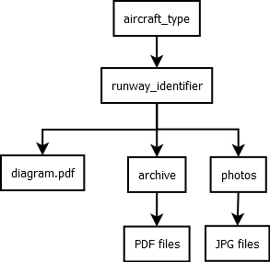

photo and archive files should be named in the following format: ZZZZ-RunwayName_20130521-01

where
ZZZZ is the 3-4 alphanumeric character unique identifier.
RunwayName is the complete name of the runway in CamelCase with no spaces.
20130521 is the date the file was created in the YYYYMMDD format.
01 is a sequential number for the iteration of that file, should more than one file with the same name be created on the same date.

    - Logical record description

The runway directories should contain the active diagram
The archive subdirectories should contain inactive diagram files
The photos subdirectories should contain photos of their corresponding runways.

    - Access method

The repository should be hosted using Windows folder sharing.

  - Global data

  - File and data cross reference

The photos are used in creating the PDF files.
The PDF files are viewed using external software, or the mobile software.

